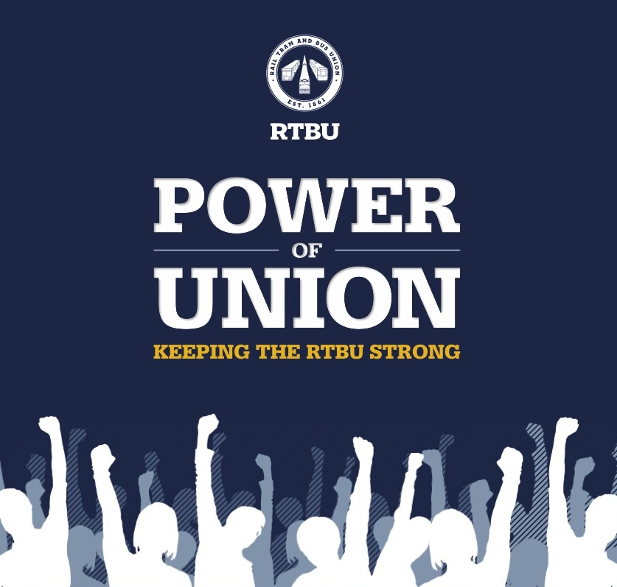

Solidarity with PNQ Drivers

